Name: A Syed Thoufiq
Reg No: 192424211
Course/Code: DSA0604 - DATA HANDLING AND VISUALIZATION
Date: 17/07/26

SET 1: MONTHLY SALES DATA
1) Line Chart – Monthly Sales
CODE:
library(ggplot2)

sales <- data.frame(
Month = c("Jan","Feb","Mar","Apr","May"),
Sales = c(15000,18000,22000,20000,23000)
)

ggplot(sales, aes(Month, Sales, group = 1)) +
geom_line(color = "blue", linewidth = 1) +
geom_point(color = "red", size = 3) +
labs(title = "Monthly Sales",
x = "Month", y = "Sales ($)") +
theme_minimal()

OUTPUT:
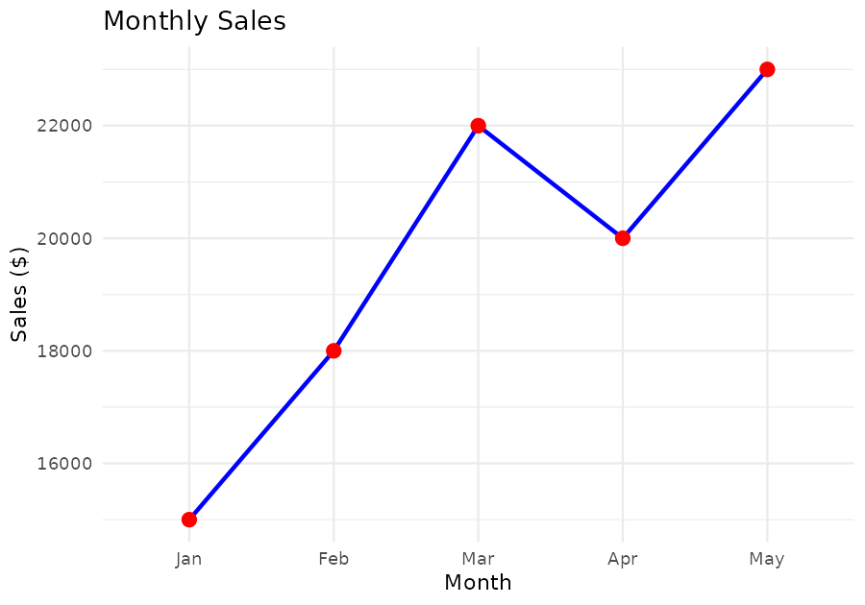

2) Bar Chart – Top Selling Products
CODE:
library(ggplot2)

products <- data.frame(
Product = c("A","B","C","D","E"),
Sales = c(45000,38000,52000,30000,41000)
)

ggplot(products, aes(Product, Sales, fill = Product)) +
geom_bar(stat = "identity") +
labs(title = "Top Selling Products",
x = "Products", y = "Sales ($)") +
theme_minimal()

OUTPUT:
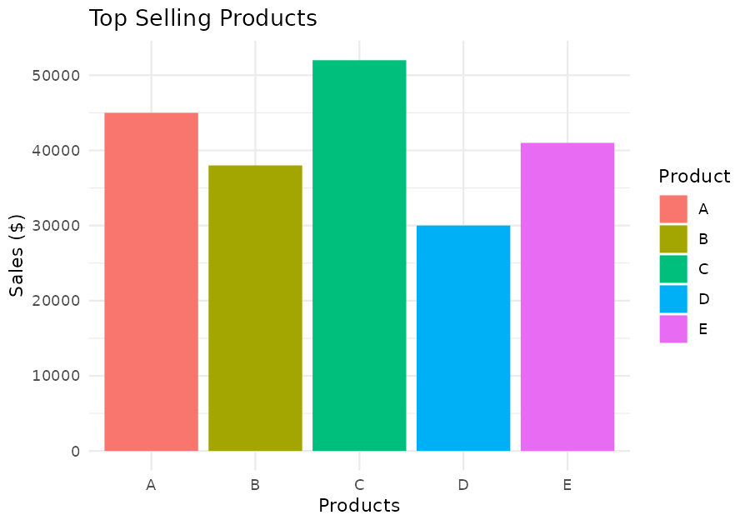

3) Scatter Plot – Advertising Budget vs Sales
CODE:
library(ggplot2)

ads <- data.frame(
Budget = c(2000,2500,3000,2800,3500),
Sales = c(15000,18000,22000,20000,23000)
)

ggplot(ads, aes(Budget, Sales)) +
geom_point(size = 3, color = "blue") +
geom_smooth(method = "lm", se = FALSE, color = "red") +
labs(title = "Advertising Budget vs Sales",
x = "Advertising Budget ($)", y = "Sales ($)") +
theme_minimal()

OUTPUT:
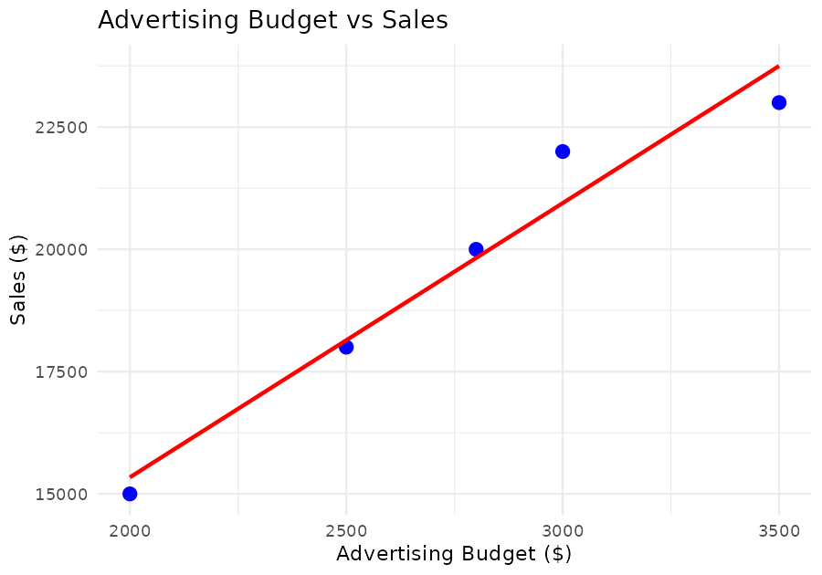

4) Interactive Dashboard (Line + Bar)
CODE:
library(ggplot2)
library(gridExtra)

p1 <- ggplot(sales, aes(Month, Sales, group = 1)) +
geom_line(color = "blue") + geom_point(color = "red", size = 3) +
ggtitle("Monthly Sales")

p2 <- ggplot(products, aes(Product, Sales, fill = Product)) +
geom_bar(stat = "identity") + ggtitle("Top Selling Products")

grid.arrange(p1, p2, ncol = 2)

OUTPUT:
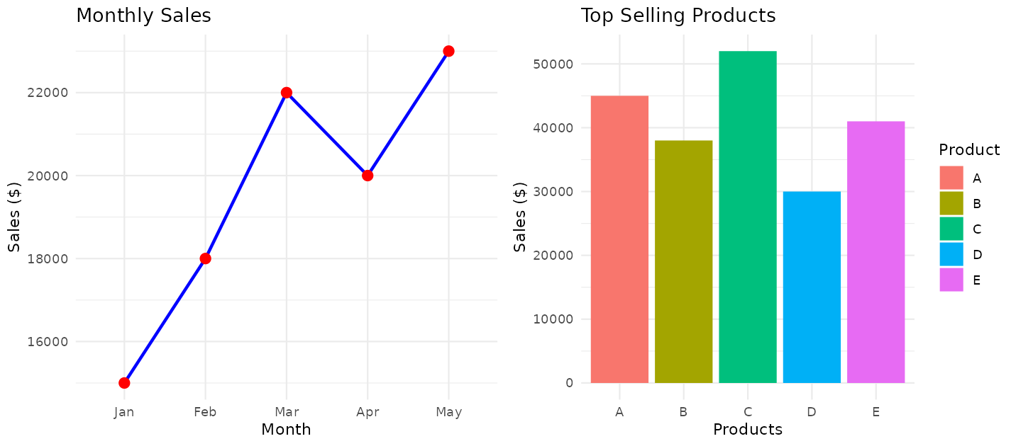

SET 2: CUSTOMER FEEDBACK ANALYSIS
1) Histogram – Distribution of Customer Ages
CODE:
library(ggplot2)

cust <- data.frame(
CustomerID = 1:5,
Age = c(25,30,35,28,40),
Satisfaction = c(4,5,3,4,5)
)

ggplot(cust, aes(Age)) +
geom_histogram(binwidth = 5, fill = "steelblue", color = "white") +
labs(title = "Distribution of Customer Ages",
x = "Age", y = "Frequency") +
theme_minimal()

OUTPUT:
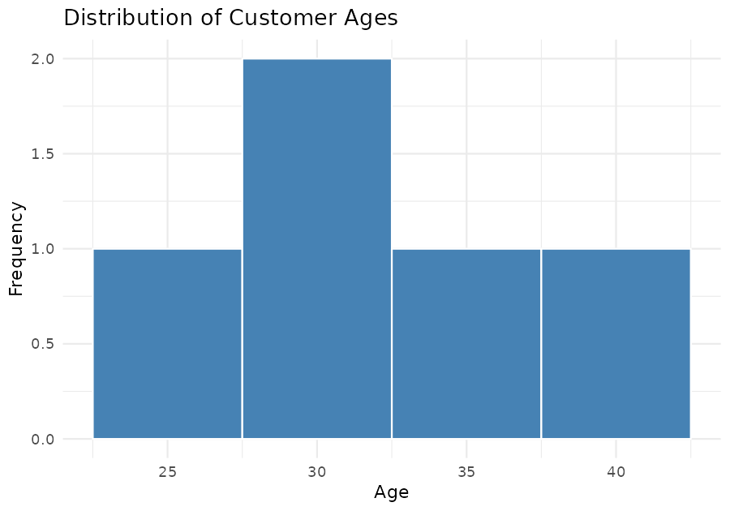

2) Pie Chart – Satisfaction Score Distribution
CODE:
library(ggplot2)

sat_counts <- as.data.frame(table(cust$Satisfaction))
colnames(sat_counts) <- c("Score", "Count")

ggplot(sat_counts, aes(x = "", y = Count, fill = Score)) +
geom_bar(stat = "identity", width = 1) +
coord_polar("y") +
labs(title = "Customer Satisfaction Score Distribution", fill = "Score") +
theme_void()

OUTPUT:
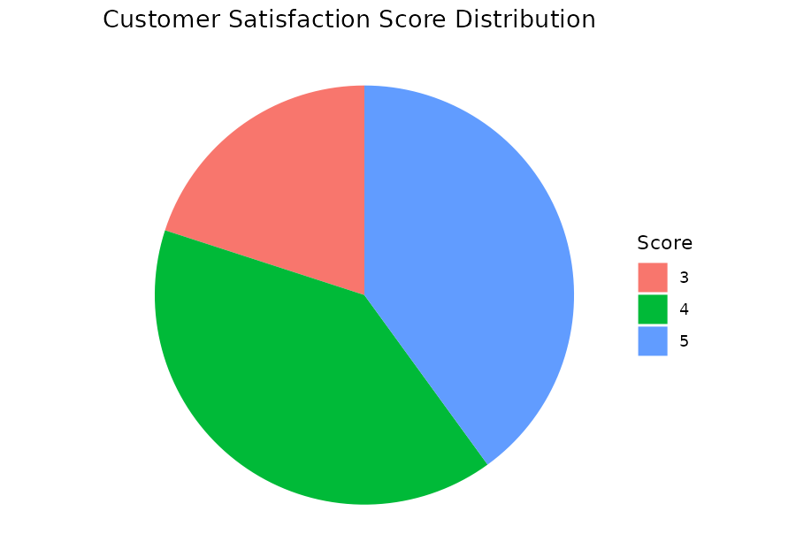

3) Stacked Bar Chart – Satisfaction Scores by Age Group
CODE:
library(ggplot2)

cust$AgeGroup <- cut(cust$Age, breaks = c(0,29,39,100),
labels = c("Under 30","30-39","40+"))

ggplot(cust, aes(x = AgeGroup, fill = factor(Satisfaction))) +
geom_bar(position = "stack") +
labs(title = "Satisfaction Scores by Age Group",
x = "Age Group", y = "Count", fill = "Satisfaction\nScore") +
theme_minimal()

OUTPUT:
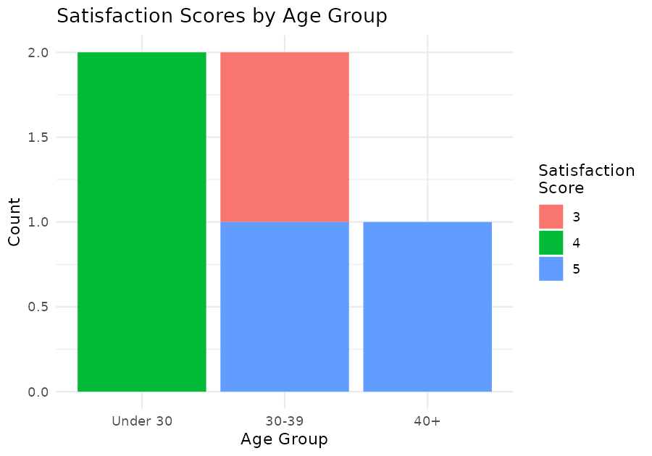

4) Word Cloud – Open-Ended Customer Feedback
CODE:
library(wordcloud)
library(RColorBrewer)

feedback <- c(
"The product quality is excellent and delivery was fast",
"Customer service was very helpful and friendly",
"Delivery took longer than expected but packaging was good",
"Great value for money and excellent support",
"The app is easy to use and checkout was smooth",
"Support team resolved my issue quickly and politely"
)

words <- unlist(strsplit(tolower(paste(feedback, collapse = " ")), "[^a-z]+"))
wt <- as.data.frame(table(words))
colnames(wt) <- c("word","freq")

wordcloud(words = wt$word, freq = wt$freq, min.freq = 1,
scale = c(3, 0.8), colors = brewer.pal(8, "Dark2"),
random.order = FALSE)

OUTPUT:
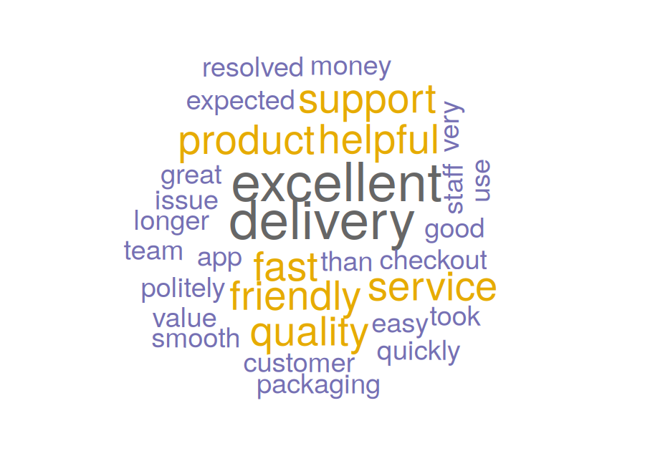

SET 3: EMPLOYEE PERFORMANCE EVALUATION
1) Line Chart – Employee Performance Trend
CODE:
library(ggplot2)

emp <- data.frame(
EmployeeID = 1:5,
Department = c("Sales","HR","Marketing","Sales","HR"),
YearsOfService = c(5,3,7,4,2),
PerformanceScore = c(85,92,78,90,76)
)

ggplot(emp, aes(x = EmployeeID, y = PerformanceScore, group = 1)) +
geom_line(color = "darkgreen", linewidth = 1) +
geom_point(color = "orange", size = 3) +
scale_x_continuous(breaks = emp$EmployeeID) +
labs(title = "Employee Performance Trend",
x = "Employee ID", y = "Performance Score") +
theme_minimal()

OUTPUT:
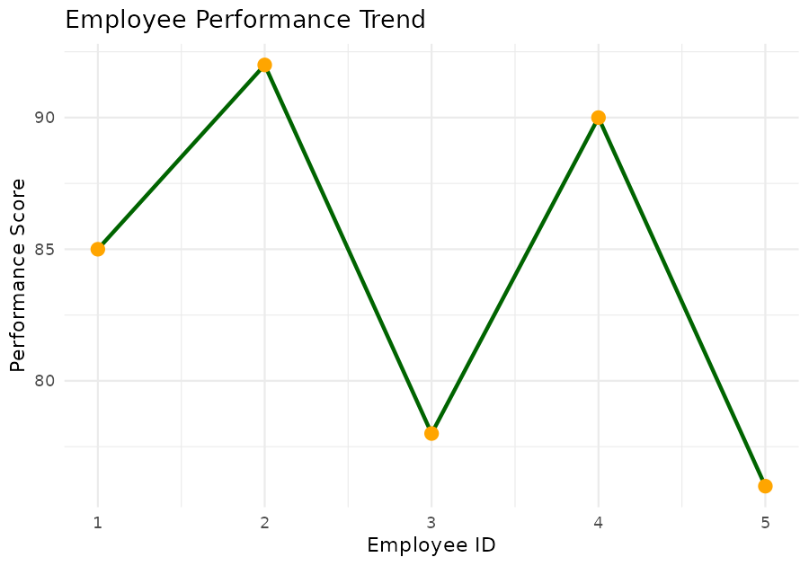

2) Bar Chart – Employees by Department
CODE:
library(ggplot2)

ggplot(emp, aes(x = Department, fill = Department)) +
geom_bar() +
labs(title = "Employees by Department",
x = "Department", y = "Number of Employees") +
theme_minimal()

OUTPUT:
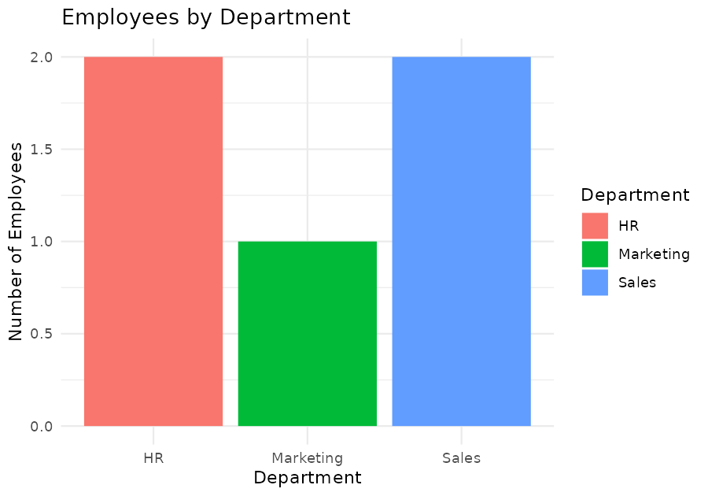

3) Scatter Plot – Years of Service vs Performance Score
CODE:
library(ggplot2)

cor(emp$YearsOfService, emp$PerformanceScore)

ggplot(emp, aes(x = YearsOfService, y = PerformanceScore)) +
geom_point(size = 3, color = "purple") +
geom_smooth(method = "lm", se = FALSE, color = "red") +
labs(title = "Years of Service vs Performance Score",
x = "Years of Service", y = "Performance Score") +
theme_minimal()

OUTPUT:
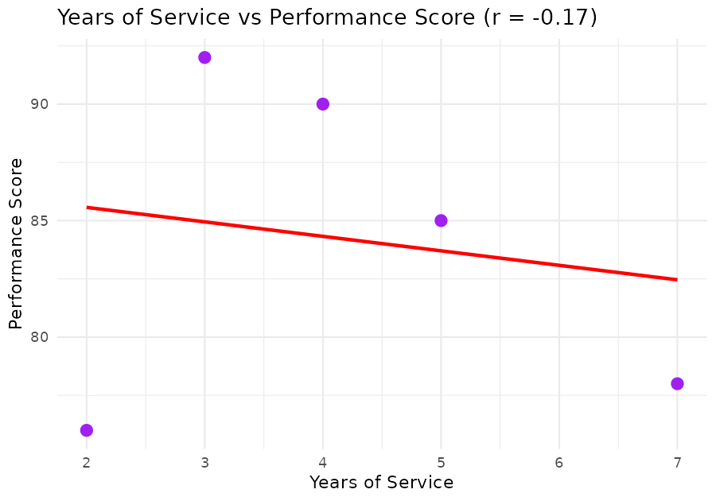

4) Tableau Dashboard – Line + Bar Chart
CODE:
library(ggplot2)
library(gridExtra)

p1 <- ggplot(emp, aes(x = EmployeeID, y = PerformanceScore, group = 1)) +
geom_line(color = "darkgreen") + geom_point(color = "orange", size = 3) +
ggtitle("Performance Trend")

p2 <- ggplot(emp, aes(x = Department, fill = Department)) +
geom_bar() + ggtitle("Department Distribution")

grid.arrange(p1, p2, ncol = 2)

OUTPUT:
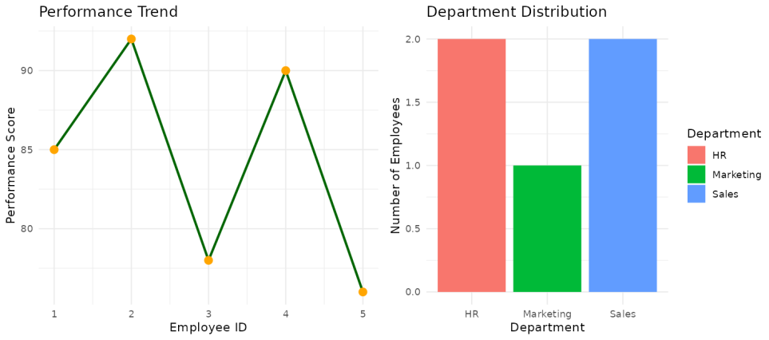

SET 4: PRODUCT INVENTORY MANAGEMENT
1) Bar Chart – Quantity of Each Product
CODE:
library(ggplot2)

inv <- data.frame(
ProductID = 1:5,
ProductName = c("Product A","Product B","Product C","Product D","Product E"),
Category = c("Electronics","Grocery","Electronics","Grocery","Home"),
Quantity = c(250,175,300,200,220),
Price = c(20,15,18,25,12)
)

ggplot(inv, aes(x = ProductName, y = Quantity, fill = ProductName)) +
geom_bar(stat = "identity") +
labs(title = "Product Inventory Quantity",
x = "Product", y = "Quantity Available") +
theme_minimal()

OUTPUT:
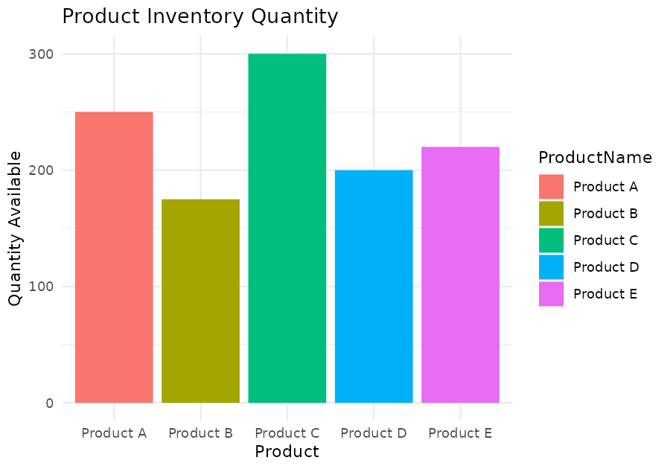

2) Stacked Bar Chart – Quantity by Product Category
CODE:
library(ggplot2)

ggplot(inv, aes(x = Category, y = Quantity, fill = ProductName)) +
geom_bar(stat = "identity", position = "stack") +
labs(title = "Quantity by Product Category",
x = "Category", y = "Quantity Available") +
theme_minimal()

OUTPUT:
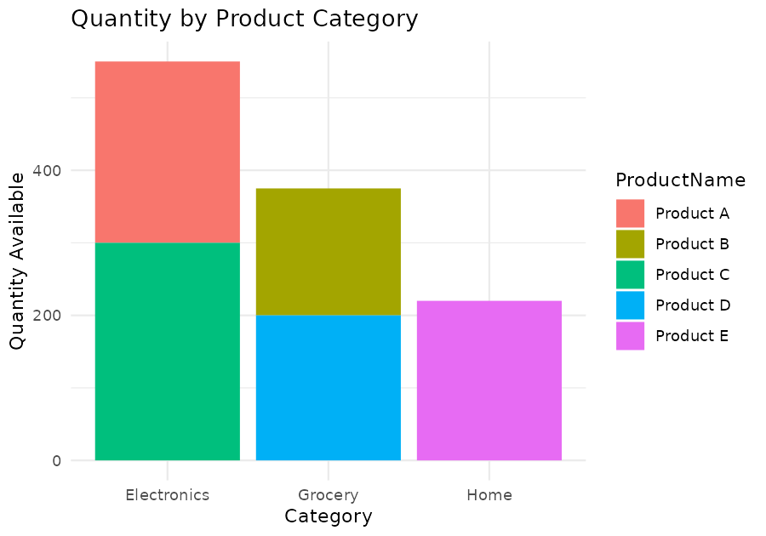

3) Scatter Plot – Product Price vs Quantity Available
CODE:
library(ggplot2)

ggplot(inv, aes(x = Price, y = Quantity)) +
geom_point(size = 3, color = "brown") +
geom_smooth(method = "lm", se = FALSE, color = "red") +
labs(title = "Product Price vs Quantity Available",
x = "Price ($)", y = "Quantity Available") +
theme_minimal()

OUTPUT:
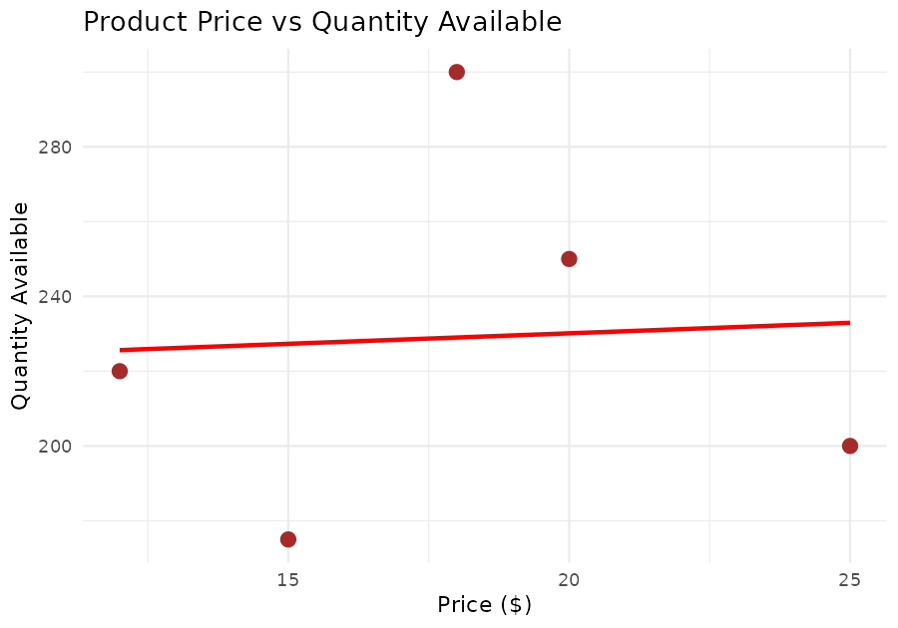

4) Tableau Dashboard – Bar + Stacked Bar Chart
CODE:
library(ggplot2)
library(gridExtra)

p1 <- ggplot(inv, aes(x = ProductName, y = Quantity, fill = ProductName)) +
geom_bar(stat = "identity") + ggtitle("Inventory Quantity")

p2 <- ggplot(inv, aes(x = Category, y = Quantity, fill = ProductName)) +
geom_bar(stat = "identity", position = "stack") +
ggtitle("Quantity by Category")

grid.arrange(p1, p2, ncol = 2)

OUTPUT:
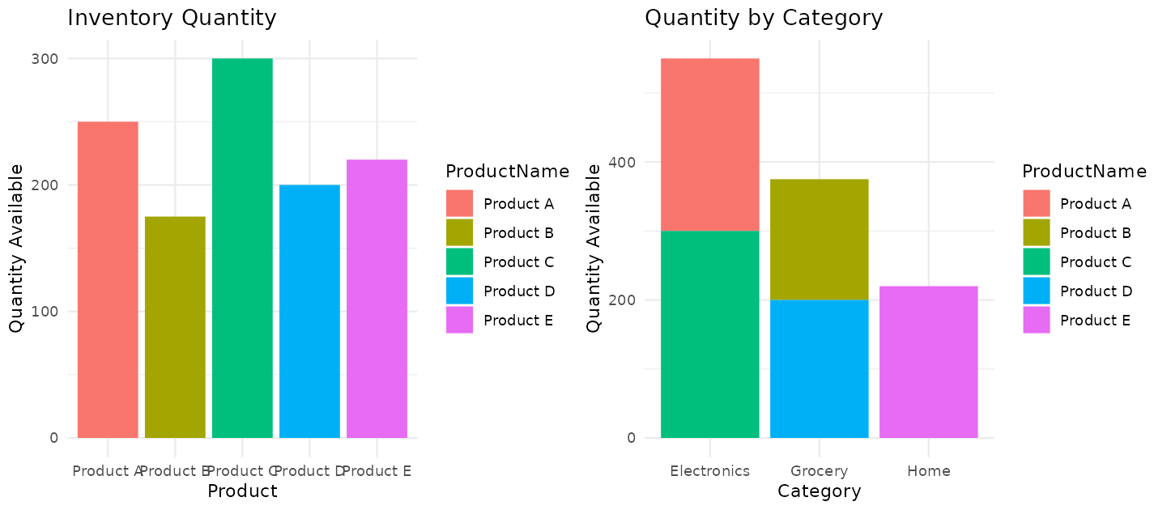

SET 5: WEBSITE ANALYTICS
1) Line Chart – Daily Page Views Trend
CODE:
library(ggplot2)

web <- data.frame(
Date = as.Date(c("2023-01-01","2023-01-02","2023-01-03",
"2023-01-04","2023-01-05")),
PageViews = c(1500,1600,1400,1650,1800),
CTR = c(2.3,2.7,2.0,2.4,2.6)
)

ggplot(web, aes(x = Date, y = PageViews)) +
geom_line(color = "steelblue", linewidth = 1) +
geom_point(color = "darkred", size = 3) +
labs(title = "Daily Page Views Trend",
x = "Date", y = "Page Views") +
theme_minimal()
OUTPUT:
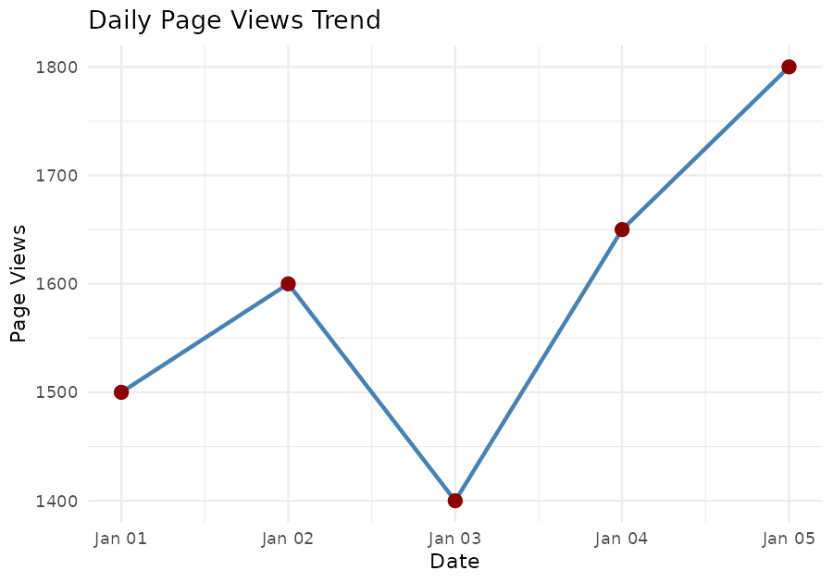

2) Bar Chart – Top Days by Click-through Rate
CODE:
library(ggplot2)

web_sorted <- web[order(-web$CTR), ]
top_n <- head(web_sorted, 3)

ggplot(top_n, aes(x = reorder(as.character(Date), -CTR), y = CTR,
fill = as.character(Date))) +
geom_bar(stat = "identity") +
labs(title = "Top 3 Days by Click-through Rate",
x = "Date", y = "CTR (%)", fill = "Date") +
theme_minimal()
OUTPUT:
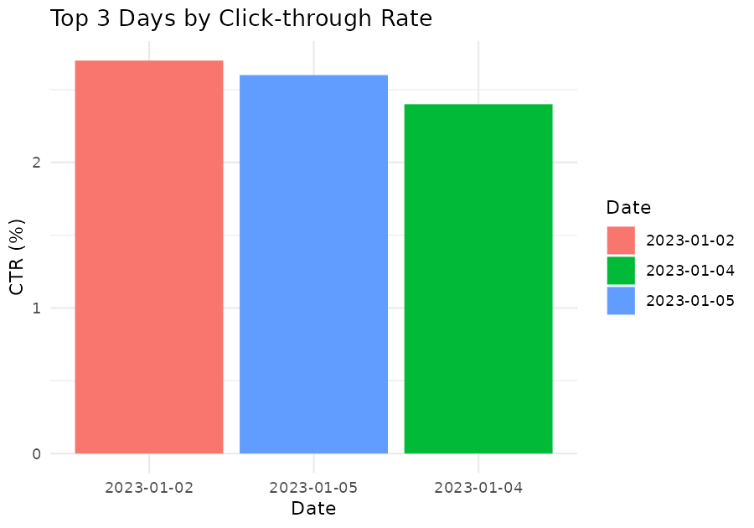

3) Stacked Area Chart – User Interactions
CODE:
library(ggplot2)

interactions <- data.frame(
Date = rep(web$Date, times = 3),
Type = rep(c("Likes","Shares","Comments"), each = nrow(web)),
Count = c(120,150,110,160,180,
40,55,35,60,65,
25,30,20,35,40)
)

ggplot(interactions, aes(x = Date, y = Count, fill = Type)) +
geom_area(position = "stack") +
labs(title = "User Interactions Over Time",
x = "Date", y = "Count", fill = "Interaction Type") +
theme_minimal()

OUTPUT:
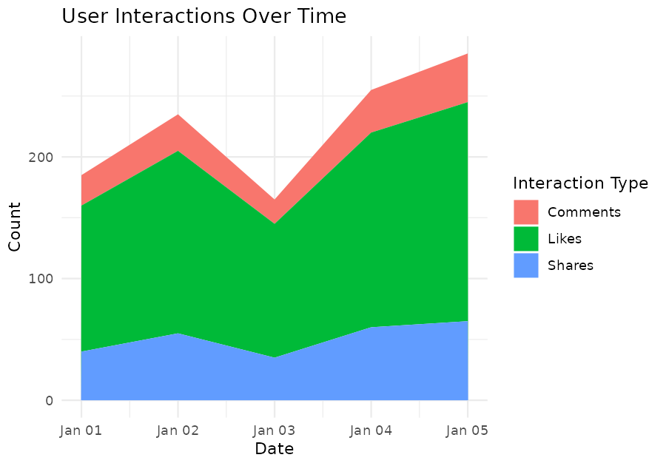

4) Tableau Dashboard – Line + Bar Chart
CODE:
library(ggplot2)
library(gridExtra)

p1 <- ggplot(web, aes(x = Date, y = PageViews)) +
geom_line(color = "steelblue") + geom_point(color = "darkred", size = 3) +
ggtitle("Page Views Trend")

p2 <- ggplot(top_n, aes(x = reorder(as.character(Date), -CTR), y = CTR,
fill = as.character(Date))) +
geom_bar(stat = "identity") + ggtitle("Top Days by CTR")

grid.arrange(p1, p2, ncol = 2)

OUTPUT:
